**Problem 2:**

Assume there is a website [https://agrichain.com](https://agrichain.com/) which does exactly the same thing as problem 1, it takes the input on home page and then on click of submit button, it navigates to different page where it prints the output for

longest substring without repeating letters.

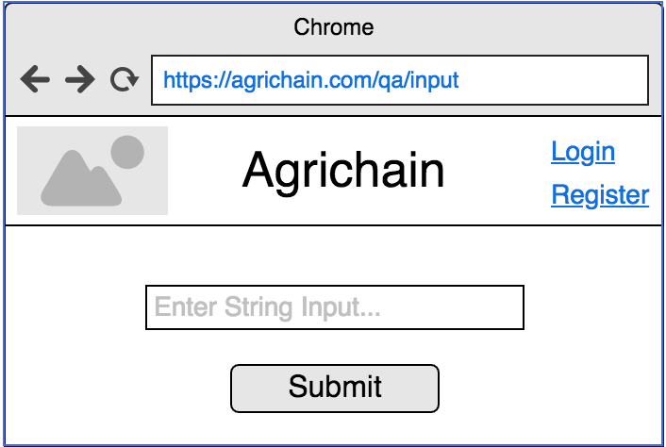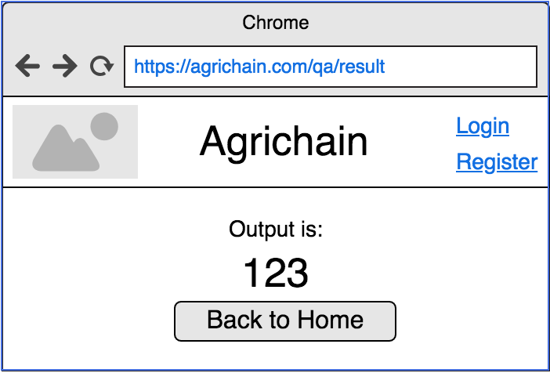

Write all test cases you would be doing to test the above website. Categorise those cases in manual (you would be doing manually) and automation (you would be automating).

Write web automation script for any one test case that you have mentioned above with

high level automation framework(folder/directory structure) to explain which goes where (browser initialisation, web elements, test scenario etc).

Note: There isn't an actual website for this, you can assume locators for all web elements on both pages as per the design shown in above screenshots.